## Configuring Hyper-V to Run Virtual Machines

**Lab Time**: 30 minutes

**Lab Folder**: C:\Student\Labs\01.SetupVM

**Lab Overview**: In the following lab, you will configure Hyper-V to run a virtual machine (VM) named **WingtipServer** that has already been built for you to use as a starting point. **WingtipServer** will be running Windows Server 2008 R2 and SQL Server 2008 R2 and has been configured as a domain control in the domain named **wingtip.com**.

Lab Setup Requirements

Before you begin this lab, locate the virtual hard disk files named **WingtipServer.vhd**. There is also a student *.ZIP that contains the lab files you will need as you are working on lab exercises. They should be located on the file system of the host computer. Verify that you have the student *.ZIP file and **WingtipServer.vhd** before you begin. If you cannot find these files on your host computer, ask your instructor for assistance before you continue.

### Exercise 1: Setup the Virtual Network on the Host Machine

In this exercise you will start up the Hyper-V Manager and ensure the proper configuration for the **WingtipServer** VM.

1. Ensure your computer hardware and software meet the following requirements.
   1. Your computer is running a 64-bit installation of Windows Server 2008 R2
   2. Your computer has a wired (non-wireless) connection to the Internet
   3. Your computer has at least 8GB of RAM
   4. Your computer has at least 120GB of free disk space.
   5. Your computer supports virtualization and has Hyper-V Services enabled.
   6. If you need more information on how to install and configure Hyper-V, you can read more at <http://www.microsoft.com/windowsserver2008/virtualization/install.mspx>.
2. Launch the Hyper-V Manager from the Windows Start menu.
3. **Start » Administrative Tools » Hyper-V Manager**. If you are using Hyper-V for the first time there will be no existing VMs in the Virtual machines section.

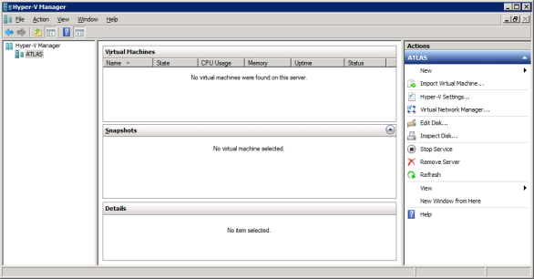

1. Create a new Virtual Network named **Internal** to connect to the Internet.
2. In the Actions pane on the right-hand side of the screen, click **Virtual Network Manager**.
   1. In the Virtual Network Manager dialog, create a new virtual network named **Internal.**
   2. Make sure the **Connection Type** of the new virtual network is configured with a setting of **Internal Only**.

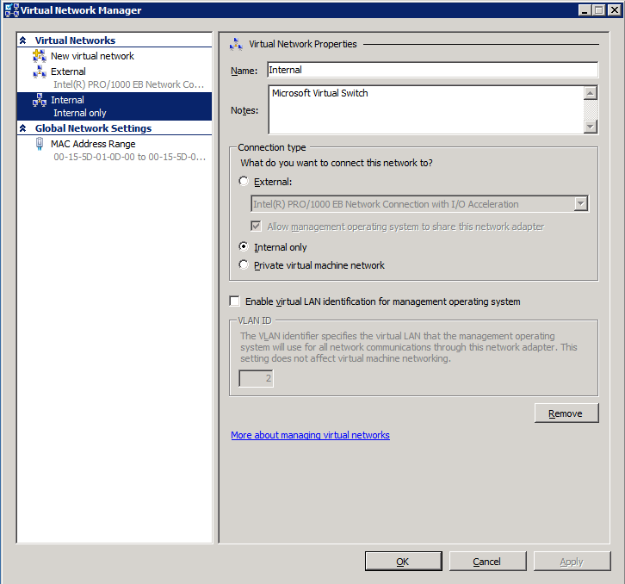

1. In the previous step you created a new private virtual network named **Internal**. When you create an internal network in Hyper-V, a new virtual network card appears on the host computer. You will configure this virtual network card with a static IP address so that host machine can connect to the VMs you will be building.
2. Right click the Network icon in the right corner of the task bar  and **choose Open Network and Sharing Center**.



* 1. In the Network and Sharing Center, select the **Change adapter settings** hyperlink.

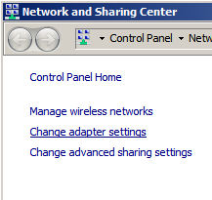

* 1. Right-click the **Internal** virtual network and choose **Properties**.

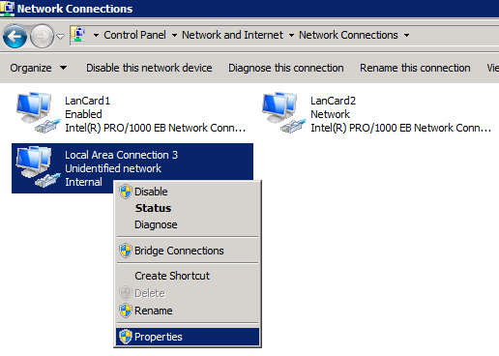

* 1. **Uncheck** the option for **Internet Protocol Version 6 (TCP/IPv6)** to disable this protocol. Now select the checked option for **Internet Protocol Version 4 (TCP/IPv4)** and click the **Properties** button to configure a static IP address.

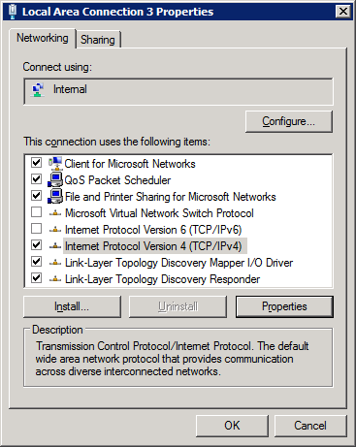

* 1. For that static IP address enter a value of **192.168.150.3** as shown in the following screenshot. Also ensure to set the Subnet mask to **255.255.255.0** and the Preferred DNS server to **192.168.150.1**. Note that the static IP address of to **192.168.150.1** will be used to configure the static IP address of the **WingtipServer** VM which will be configured as an Active Directory domain controller as well as a DNS server.

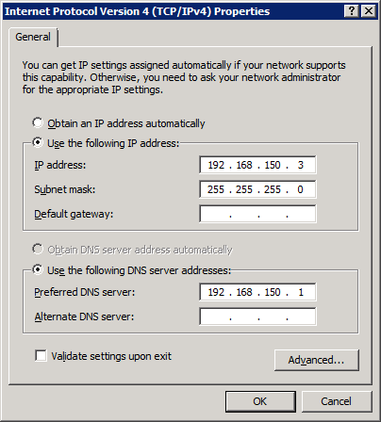

### Exercise 2: Setup the Virtual Machine using Hyper-V

In this exercise you will create the virtual machine for the SharePoint 2010 labs.

1. Create a virtual machine for the Wingtip server.
2. Inside the Hyper-V Manager, right click on the host machine node and click the menu command **New > Virtual Machine**.

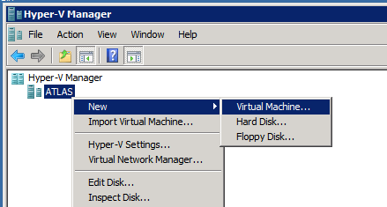

* 1. On the first page of the wizard you have to specify a name for the new virtual machine. Give it the name **WingtipServer**. Click the **Next** button.

1. On this page you have to assign memory to the virtual machine. Depending on the power of your machine, you have to assign at least **6144 MB** to it. Click the **Next** button.
2. On the next page you have to configure networking. Select the virtual network named **Internal** from the **Connection** dropdown list. Click the **Next** button.
3. On the next page you have to connect to a virtual hard disk. Choose the **Use an existing virtual hard disk** and click the **Browse** button to navigate to the location of the **WingtipServer.vhd** file. Click the **Next** button.
4. The last page contains a summary of the details you specified in the previous pages. Click the **Finish** button to create the new virtual machine.

Note that the classroom setup requirements for this training class call for a minimum of 8GB of RAM on the student workstation running Hyper-V. If you only have 6GB of RAM, then you should configure the WingtipServer VM with 5120 MB of RAM. This will allow you to get through the labs, just with slower performance. If your Hyper-V host computer has less than 6GB or RAM you will not be able to complete these lab exercises until you increase the amount of RAM.

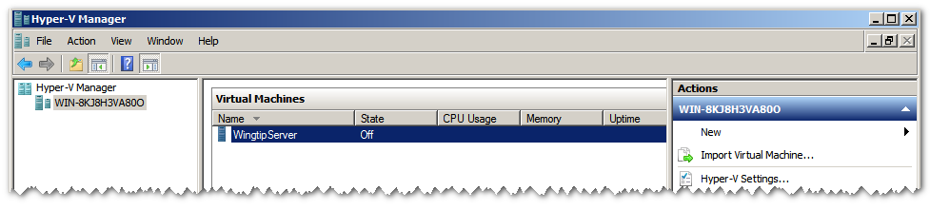

### Exercise 3: Log on to the WingtipServer Virtual Machine

In this exercise you will log into the WingtipServer and check the settings.

1. In the **Hyper-V Manager** right click on the **WingtipServer** VM and click the **Start** menu command to start the VM up. Give the VM a minute or two to start up.

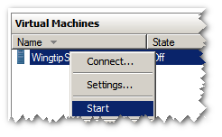

1. Once the VM has completed its startup procedures, log in using the Hyper-V Console Window.
2. In the **Hyper-V Manager** right click on the **WingtipServer** VM and click the **Connect** menu command to bring up the Hyper-V Console Windows.
   1. Drop down the **Action** menu in the Hyper-V Console Window for the **WingtipServer** VM and click the **[**Ctrl]+[Alt]+[Delete] menu command.

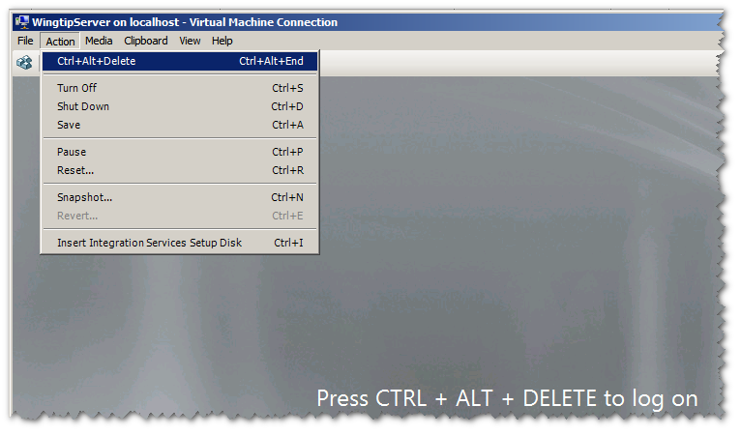

1. Log on to the VM using **WINGTIP\Administrator** user account.
2. Ensure the network card on the **WingtipServer** is configured correctly.
3. Right click the Network icon in the right corner of the task bar and **choose Open Network and Sharing Center**.



* 1. In the Network and Sharing Center, select the **Change adapter settings** hyperlink.



* 1. Right-click the virtual network for the network adapter associated with the **Internal** private network and **Properties**.

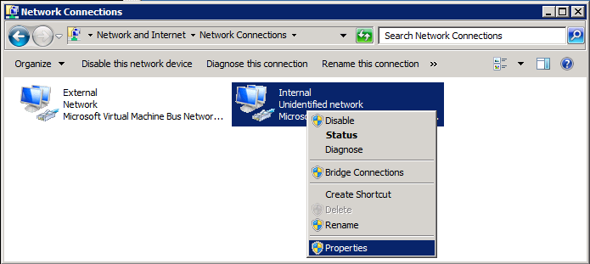

* 1. Uncheck the option for **Internet Protocol Version 6 (TCP/IPv6)** to disable this protocol. Now select the checked option for **Internet Protocol Version 4 (TCP/IPv4)** and click the **Properties** button to configure a static IP address.

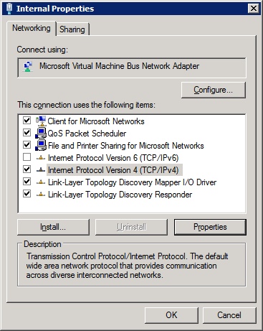

* 1. For that static IP address enter a value of **192.168.150.1** as shown in the following screenshot. Also ensure to set the Subnet mask to **255.255.255.0** and the Preferred DNS server to **127.0.0.1**. Note that the static IP address of to **192.168.150.1**will be used to configure the static IP address of the **WingtipServer** VM which will be configured as an Active Directory domain controller as well as a DNS server.

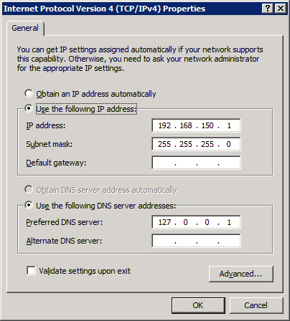

* 1. Click **OK** to dismiss all the open dialogs.

### Exercise 4: Configuring Remote Desktop Connection

In this exercise you will connect to the virtual machine using a Remote Desktop Connection.

1. Log onto the **WingtipServer** VM using the Hyper-V console.
2. Click on the Windows **Start** menu and locate the **Computer** menu. Right click on the **Computer** menu and select the **Properties** menu command to bring up the **System** page.

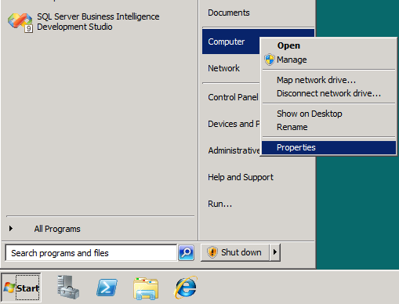

1. On the **System** page, locate and click the link labeled **Remote Settings**.

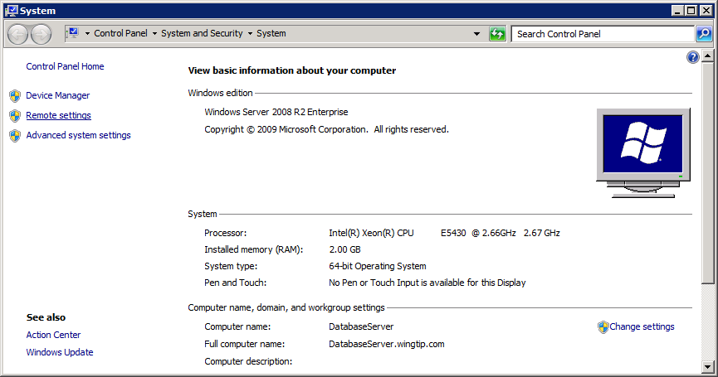

1. On the **Remote** tab of the **System Properties** dialog, locate the **Remote Desktop** section. Ensure that the settings in the **Remote Desktop** section has the last option selected to **Allow connections only from computers running Remote Desktop with Network Level Authentication (more secure)**.

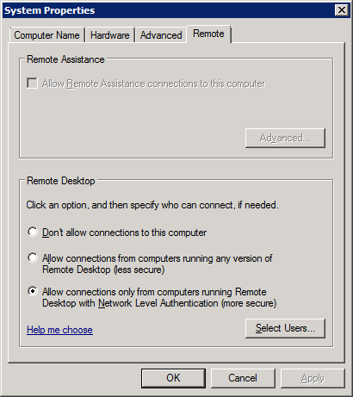

1. Locate and click the button with the caption of **Select Users** to bring up the **Remote Desktop Users** dialog. Add the built-in Active Directory group named **WINGTIP\Domain Users**. In later labs, this setting will allow standard users who are not administrators to log into the **WingtipServer** VM.

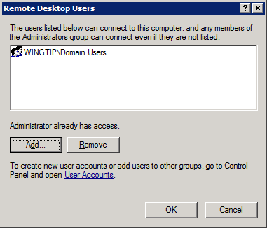

1. Click **OK** to dismiss all dialogs.
2. Close the Hyper-V console windows for the **WintipServer** VM.

Now, you have configured remote, it is time to create RPD connection from the host computer the VM to ensure remote access is properly configured.

1. Make sure you are working on the host computer and the VM is running.
2. Bring up the dialog to create a Remote Desktop Connection from the Windows Start menu by using the command **Start » All Programs » Accessories » Remote Desktop Connection**.

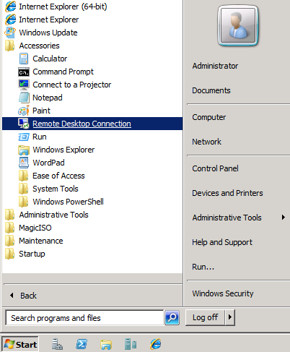

1. On the Remote Desktop Connection dialog, click the **Options** button to see more settings. Now fill information in the **General** tab as shown below to connect to the **WingtipServer** VM using a Computer setting of **192.168.150.1** and a user name setting of **WINGTIP\Administrator**. Also make sure to check the option for **Allow me to save credentials** so you will not be required to continually type in the password.

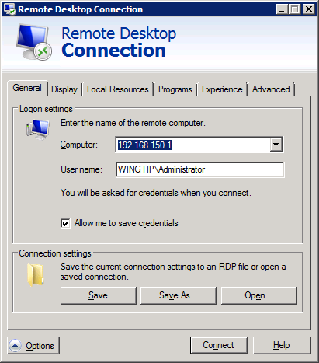

1. Click the **Save As** button and save this connection information to an *.RDP file on the desktop named Wingtip Server.rdp. Do not close the Remote Desktop Connection dialog.

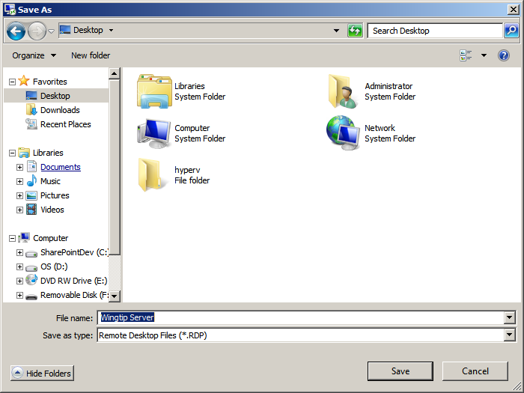

1. At this point, you should see the*.RDP files on your desktop.

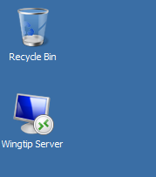

1. Double click on Wingtip Server.rdp to establish a Remote Desktop connection to the **WingtipServer** VM. A dialog might appear asking if you trust the connection to the remote computer. Select “Don’t ask me again for connections to this computer” and click **Connect** if you are prompted. The first time you do this, you will be prompted for the password. Enter the password and make sure you have the **Remember my credentials** option checked so you will not have to enter the password in the future.

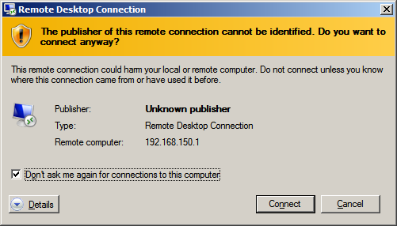

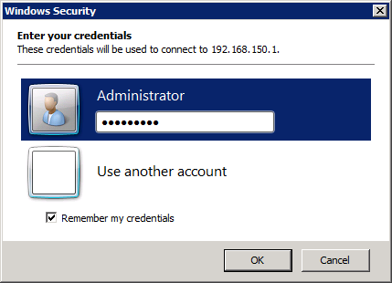

1. After you have successfully entered the password, you will be prompted with another dialog that asks you if you want to connect despite some issues with certificates and the lack of a trusted authority. Make sure you select the option **Don't ask me again for connections to this computer** and click **Yes**.

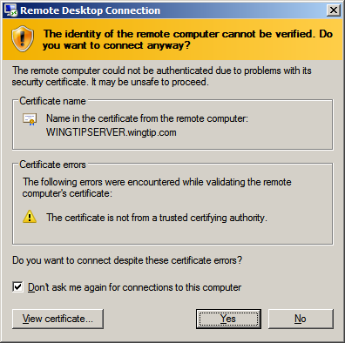

### Exercise 5: Copy the Student Lab files to the VM

In this exercise, you will copy and extract the student files to the WingtipServer virtual machine.

1. On your host computer, you should have a set of student lab files inside a *.ZIP archive. Locate thisfile. If you cannot find it, ask your instructor for assistance.
2. Copy the *.ZIP archiveto the local file system of the **WingtipServer** VM.
3. Expand the files from the *.ZIP archive into a new directory named **C:\Student** on the local file system of the **WingtipServer** VM
4. When you are done, the VM should now have a local copy of the student files at **C:\Student**.